## MRE_Scale_DIM_L0

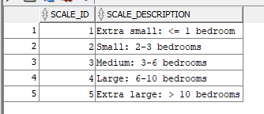

## MRE_Feature_Cat_DIM_L0

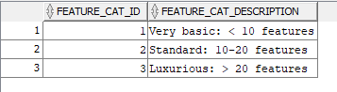

## MRE_Property_DIM_L0

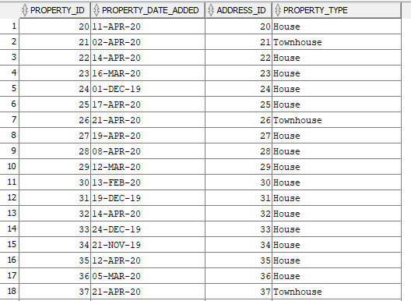

## MRE_Property_Feature_Bridge_L0

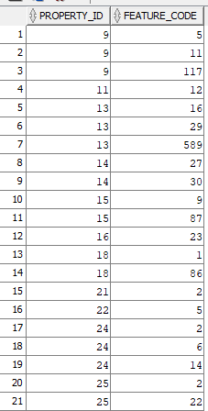

## MRE_Feature_DIM_L0

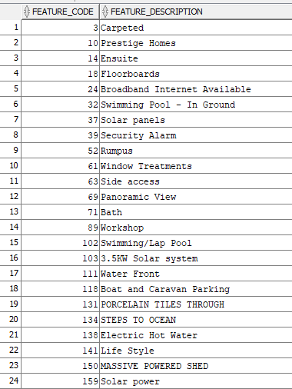

## MRE_Wishlist_DIM_L0

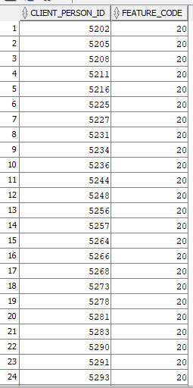

## MRE_Property_Type_DIM_L0

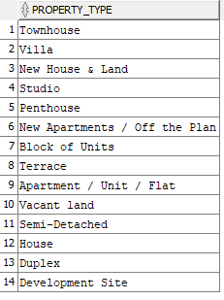

## MRE_Address_DIM_L0

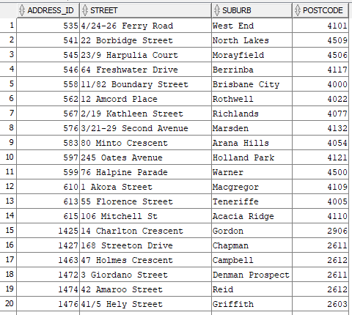

## MRE_Postcode_DIM_L0

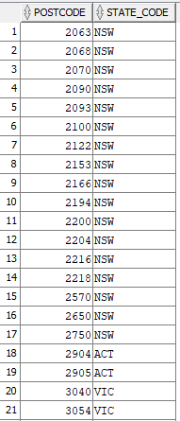

## MRE_State_DIM_L0

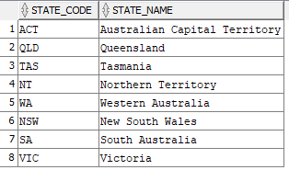

## MRE_Advertisement_DIM_L0

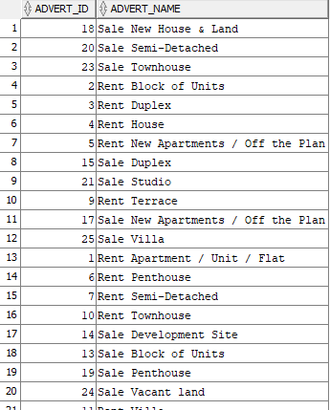

## MRE_Person_DIM_L0

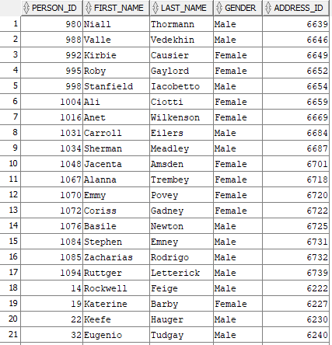

## MRE_Agent_Office_DIM_L0

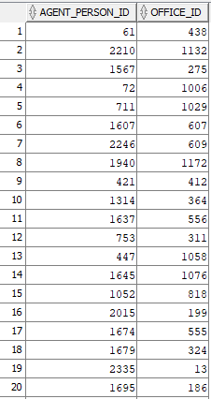

## MRE_Office_DIM_L0

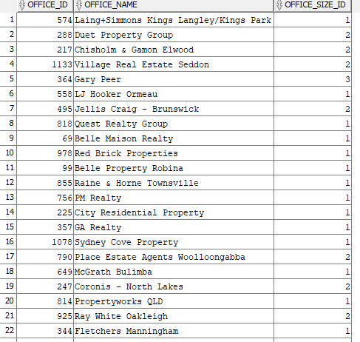

## MRE_Office_Size_DIM_L0

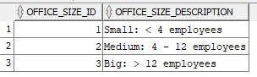

## MRE_Budget_DIM_L0

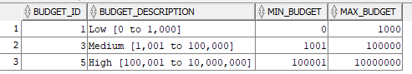

## MRE_Rental_Period_DIM_L0

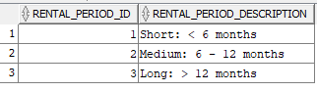

## MRE_Rent_Price_DIM_L0

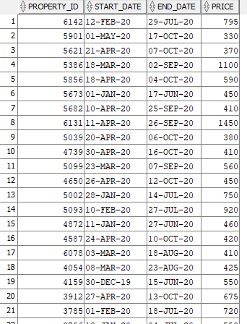

## MRE_Season_DIM_L0

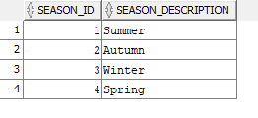

## MRE_Time_DIM_L0

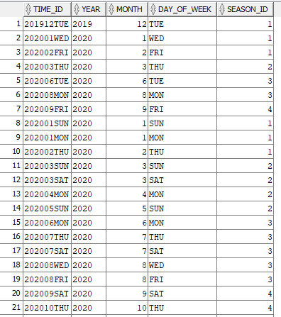

## MRE_Sale_FACT_L0

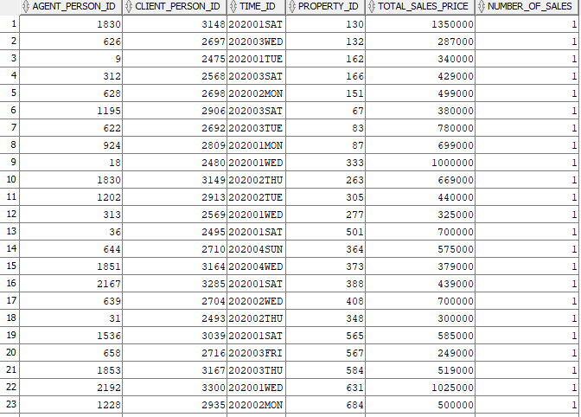

## MRE_Rent_FACT_L0

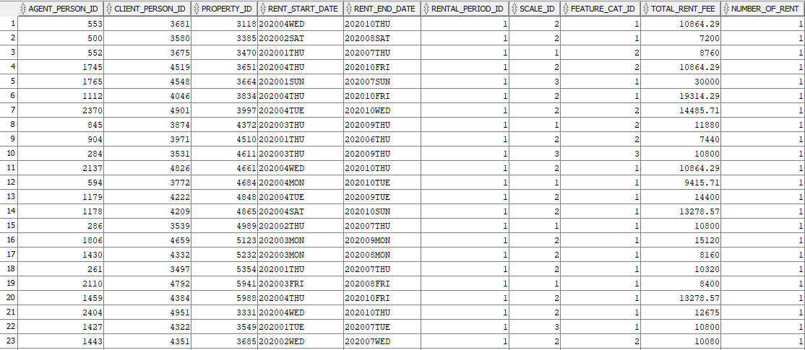

## MRE_Client_FACT_L0

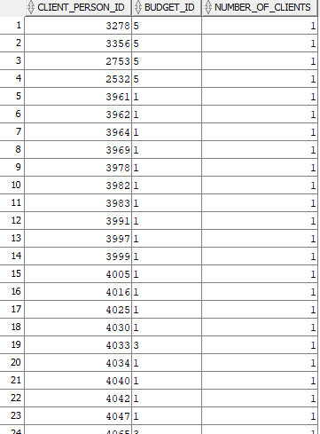

## MRE_Agent_FACT_L0

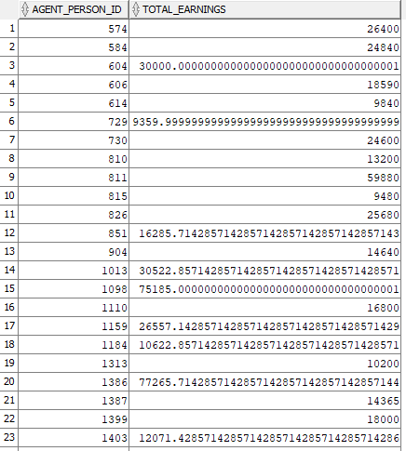

## MRE_Visit_FACT_L0

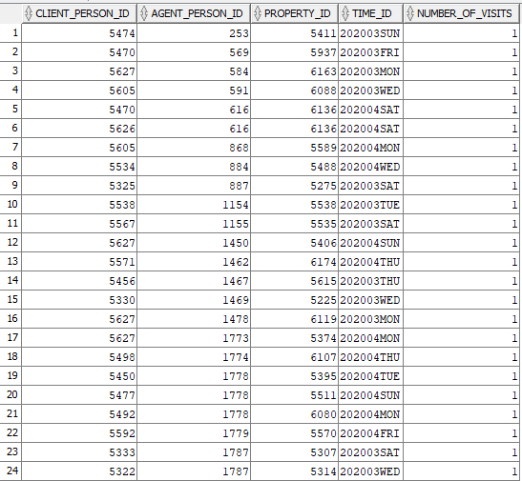

## MRE_Advert_FACT_L0

